Tokyo Bay Aqua Line

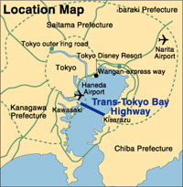
- 8 miles long
- 2 mile causeway
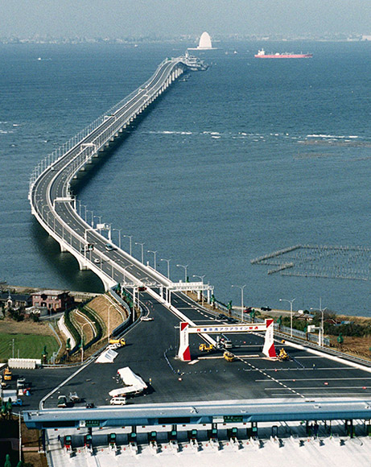

- 6 mile tunnel
- The tunnel is the longest underwater tunnel in the world.
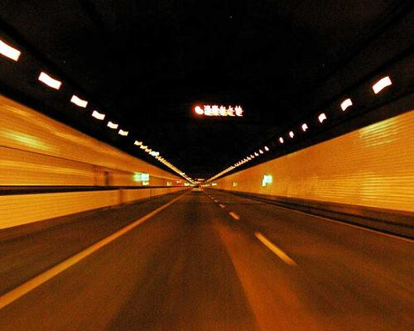
- It took 31 years to complete, at a cost of 1.44 trillion yen (11.2 billion)
- It reduces the commute between Chiba and Kanagawa, two important industrial regions, from 90 minutes to 15 minutes.
- It was expected to reduce traffic through Downtown Tokyo, which turned out to be an epic fail.
- It has an artificial island called “Umihotaru” meaning “sea firefly”. It serves as the transition between bridge and tunnel. It has restaurants, shops, and amusement facilities (?).
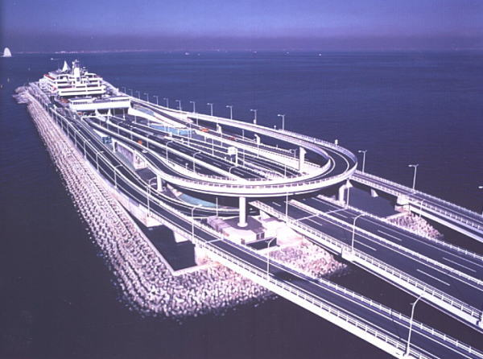
- Air is supplied by a giant tower appropriately named “The Tower of Wind” (Kaze no Tō)
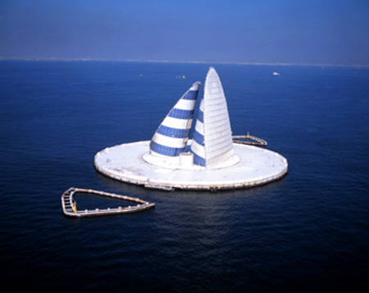
- Toll is 3000 yen, which is about $33.
- One close cousin is the Chesapeake Bay Bridge-Tunnel.

